Waste Identification and Classification Management AI Model

Student number: S1039955

abstract
AI models have enabled the intelligent management of waste disposal for humanity. The identification and classification are the core aspects. This article focuses on the application of AI models in this scenario, clarifying the attributes and characteristics of waste, integrating image recognition technology to achieve precise and efficient classification, and providing practical references for improving the economic recycling management efficiency of recyclable waste and facilitating environmental protection intelligence.

Introduction
In the current era where global environmental issues are becoming increasingly severe, efficient classification and disposal of waste has become a crucial step in achieving resource recycling and alleviating ecological pressure. Traditional waste identification and classification mainly rely on manual sorting, which not only consumes a large amount of manpower and time resources, but is also susceptible to subjective judgment, work intensity and other factors, resulting in low classification efficiency and unreliable accuracy. It has thus failed to meet the requirements of modern waste disposal systems. The rapid development of deep learning technology has provided a brand-new solution for waste identification through the image recognition technology based on convolutional neural networks (CNN). The CNN architecture, through convolution, weight sharing and pooling operations, can automatically extract multi-level features from images, ranging from low-level features such as texture and color on the surface of the waste to high-level features such as shape and structure. This overcomes the limitations of manual feature extraction in traditional machine learning methods. Developing a waste identification model based on the CNN architecture not only enables the automation and intelligence of waste classification, significantly improving the efficiency and accuracy of the waste disposal process, providing core technical support for the construction of a smart sanitation system, but also promotes the improvement of resource recovery utilization rate and helps achieve the goals of "carbon peak and carbon neutrality"(Zhang et al.,2022).
Methodology

Neural networks have become an important tool for modern image classification, with their advantage being the ability to automatically learn hierarchical feature representations from raw image data. Unlike traditional machine learning methods that rely on manually designed features, neural networks, especially convolutional neural networks (CNNs), can simultaneously capture low-level visual features such as edges and textures, as well as high-level semantic patterns such as shapes and object structures. This makes them significantly superior when dealing with complex and diverse image datasets(Janiesch et al.,2021).
Neural network classification of image datasets typically involves several key steps: data preprocessing, feature extraction by the network, training optimization, and model evaluation. During data preprocessing, images are usually uniformly resized to a fixed resolution to ensure consistent input dimensions and normalized pixel values, thereby enhancing the stability of gradient optimization(Huang et al.,2023). Additionally, data augmentation techniques such as random flipping, rotation, cropping, and color adjustment are commonly employed to increase data diversity and improve the generalization ability of the model. The preprocessed images are then input into the network, which consists of multiple layers of convolution, pooling, nonlinear activation, and fully connected layers, for feature extraction and final classification.
In a Convolutional Neural Network (CNN), the convolutional layer is the core component for feature extraction. The network learns convolutional kernels (also known as filters) and performs sliding convolution operations on the input image to extract local feature maps. These convolutional kernels can capture low-level patterns in the image, such as edges, textures, color changes, and local shape information. As the number of network layers increases, the convolutional layer can combine the low-level features extracted by the previous layer to form higher-level, abstract feature representations, enabling the network to gradually understand the complex spatial structure and semantic content of the image. Each convolution operation is usually accompanied by zero padding and stride settings to control the size of the output feature map and the degree of information retention, thereby obtaining feature representations of different scales at different levels(Pang et al.,2018). The pooling layer is another crucial component in CNNs. Its main function is to reduce the spatial dimension of the feature map, decrease the number of model parameters and computational load, and introduce a certain degree of translational invariance, enabling the network to maintain robustness in the presence of slight displacements or deformations of objects in the image. Common pooling methods include max pooling and average pooling. Max pooling retains the maximum value in a local area, emphasizing the most significant feature responses, which helps the network focus on key areas. Average pooling, on the other hand, retains the overall information of the area, providing a smoother feature representation in some tasks. The pooling operation not only helps in feature compression but also reduces the risk of overfitting to a certain extent(Sun et al.,2017). To enhance the expression ability and nonlinear fitting capability of the network, convolutional layers and fully connected layers are usually used in combination with nonlinear activation functions, such as ReLU (Rectified Linear Unit). ReLU can effectively alleviate the problem of gradient disappearance, ensuring stable gradient transmission during the training of deep structures of the network, and also enabling it to fit complex nonlinear data relationships. Moreover, in the fully connected layer, to prevent the model from overfitting to the training data, Dropout regularization is often introduced. Dropout randomly masks the outputs of some neurons during training, forcing the network to learn on a limited number of activation units, thereby improving the generalization ability and robustness of the model. After multiple layers of convolution, pooling and activation function operations, the multi-channel feature maps obtained will be flattened (Flatten) and input into the fully connected layer for information integration(Basha et al.,2020)The fully connected layer maps the spatial local features to the global feature space, providing a complete feature representation for classification decisions. Finally, the output layer usually uses the Softmax activation function to convert the network prediction results into a probability distribution for each class, making the output values interpretable and facilitating the calculation of Cross-Entropy Loss for model training. The entire convolutional neural network, through layer-by-layer feature abstraction and information integration, can automatically learn discriminative feature representations from the original image, achieving high-precision image classification.
During the network training phase, parameter updates are achieved by optimizing the loss function. For multi-class classification tasks, the categorical cross-entropy loss function (Categorical Cross-Entropy) is typically used. Optimizers such as Adam or momentum-based SGD are widely employed, as they can adaptively adjust the learning rate and accelerate the convergence speed. During the training process, the model's performance on unseen data is monitored using the validation set, and techniques such as EarlyStopping, Dropout, or weight regularization are employed to prevent overfitting, thereby ensuring the model's generalization abilit.
After the training is completed, the model is evaluated on an independent test set to measure its classification performance on new samples(Maier et al.,2023). Common evaluation metrics include overall classification accuracy, accuracy rates for each category, confusion matrices, as well as precision, recall, and F1 scores, etc. By plotting the training/validation accuracy curves and confusion matrix graphs, the learning process of the model and its classification effects on each category can be intuitively analyze.
Simulations
The image dataset used in this study consists of four types of targets: battery, biological, cardboard, and metal, totaling 4666 color images. All samples were captured from actual scenes, with resolutions ranging from 200×200 to 500×500. The images show significant differences in lighting, angles, and background clutter, representing the complexity of real environments. The dataset is divided into training set, validation set, and test set in a ratio of 7:1.5:1.5 to ensure consistent category distribution. Each category contains diverse samples, such as the battery category featuring batteries of different shapes and colors; the biological category presenting natural textures like leaves and fruit skins; the cardboard category featuring mostly regular geometric surface shapes; and the metal category demonstrating reflective material characteristics. Figure dateset sample shows typical sample images of each category to illustrate the diversity and representativeness of the dataset.
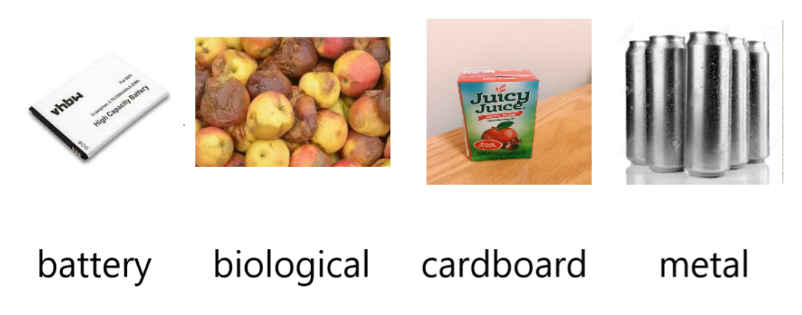
Dataset sample

This experiment employs a deep learning model based on Convolutional Neural Network (CNN) to classify and recognize multi-category image data. The overall network structure mainly consists of four parts: input data preprocessing, convolution feature extraction module, feature flattening and high-dimensional abstract expression module, and the final Softmax classifier. Firstly, during the input data processing stage, the model normalizes the original images through Rescaling (1. / 255), mapping the pixel values from 0–255 to the 0–1 range. This reduces the numerical differences between different samples, thereby enhancing the stability of training and the efficiency of gradient optimization. The image input size is uniformly set to 224×224×3, which not only ensures compatibility with mainstream CNN networks but also reduces computational load while maintaining visual details. In the feature extraction module, the network sequentially stacked three convolution and pooling combinations to form a typical hierarchical convolution architecture. The first group of convolution layers contained 32 convolution kernels of size 3×3, which were designed to extract low-level features from the original image, such as edges, corners, and basic textures. The second group of convolution layers increased the number of convolution kernels to 64, enabling the network to capture more complex local structures, such as curve contours and texture combinations. The third group of convolution layers further expanded to 128 convolution kernels to learn high-level semantic features, including the shape of object regions, local configurations, and category feature patterns. Each convolution layer employed the ReLU activation function to enhance the model's nonlinear expression ability and improve training efficiency by effectively avoiding gradient disappearance. After each convolutional module, the network adds a 2×2 max pooling layer to reduce the spatial resolution of the feature maps. The pooling operation not only reduces the computational cost and parameter size of the model, but also enhances the ability to handle local translations, small deformations and noise interference, which are the characteristics of CNN convolutional neural networks. After feature extraction is completed, the model uses the Flatten layer to flatten the multi-dimensional convolutional features into a one-dimensional vector, entering the fully connected feature mapping stage. The subsequent Dense layer contains 256 neurons, mainly used to integrate the convolutional features into a high-dimensional semantic representation, enabling the model to infer category-related information from rich visual features. To further prevent overfitting of the model, this study introduces Dropout (with a proportion of 0.5) after this fully connected layer. It randomly masks some neural connections, thereby reducing the network's excessive reliance on certain features and improving generalization performance. Finally, the network generates a probability distribution for num_classes of categories through an output layer with a Softmax activation function, achieving the final multi-class classification. The Softmax function ensures that the sum of the output probabilities is 1, enabling the model to produce interpretable classification results. For details, please refer to the structural image.
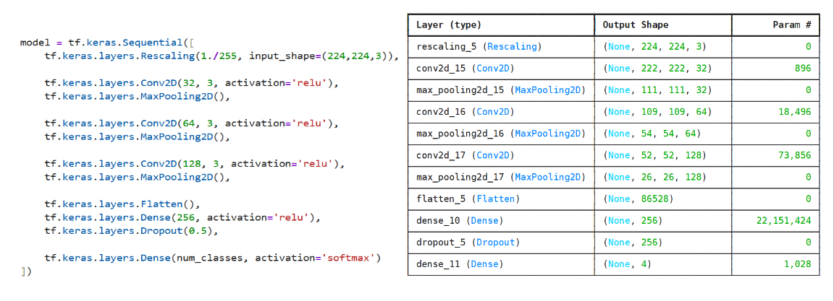
Structural image
The dataset is divided into training set, validation set and test set in the ratio of 70%–15%–15%. Among them, the training set is used to update the model parameters; the validation set is used for model selection and hyperparameter adjustment; the test set is used for the final objective evaluation of the model performance. During the division process, the category distribution is kept consistent to avoid the situation where a certain category of samples has an excessively high proportion in a certain subset, which may lead to bias. During the training phase, the model performs feature extraction and prediction on the training set samples through forward propagation. Then, the cross-entropy loss function is used to measure the error between the predicted results and the true labels. Based on this error, the model conducts backpropagation and updates all the trainable parameters in the network. This study adopts a mini-batch training strategy to enhance training stability and computational efficiency. The batch size is typically set to 32 to achieve a balance between computing resources and gradient estimation noise. In terms of optimization algorithms, this study selects Adam as the main learning algorithm. Adam combines the advantages of momentum and RMSProp, and achieves adaptive learning rate adjustment through first and second moment estimation of the gradients. Its update method can effectively avoid oscillations caused by excessively large learning rates, and also avoid slow convergence due to excessively small learning rates. Therefore, it is particularly suitable for deep models with large parameter quantities such as convolutional neural networks. The initial learning rate is set at 1×10⁻³, and combined with a learning rate decay strategy, the learning rate is automatically reduced when the loss on the validation set no longer improves for several rounds, in order to further improve the convergence quality. During the training process, this study also conducts real-time monitoring of the model's generalization performance through the validation stage. The validation set does not participate in the gradient update and is only used to evaluate the model's performance on unseen data. By observing the trends of validation loss and validation accuracy, it is possible to determine whether the model begins to overfit. To prevent the model from forgetting its generalization ability by memorizing the training data, this study adopts the Early Stopping strategy: if the validation loss does not significantly decrease in consecutive several rounds (for example, 10 rounds), the training is prematurely terminated and the model weights with the best performance are retained. This strategy not only improves the model's generalization ability but also avoids unnecessary training computational costs. In the final testing stage, the model is independently evaluated using the test set that was never involved in the training process. The testing stage only performs forward propagation and does not undergo any parameter updates, thus being able to truly reflect the model's final generalization ability. This study uses classification accuracy as the main indicator and uses the confusion matrix to evaluate the model's ability to distinguish different types of samples. The confusion matrix can show the correct prediction quantities and misjudgment situations of each category, thereby providing a basis for further model optimization. The model was finally trained for 38 rounds and was stopped by Early Stopping at the 18th round. The best performance of the model was achieved at this point. For more details, please refer to the training image.
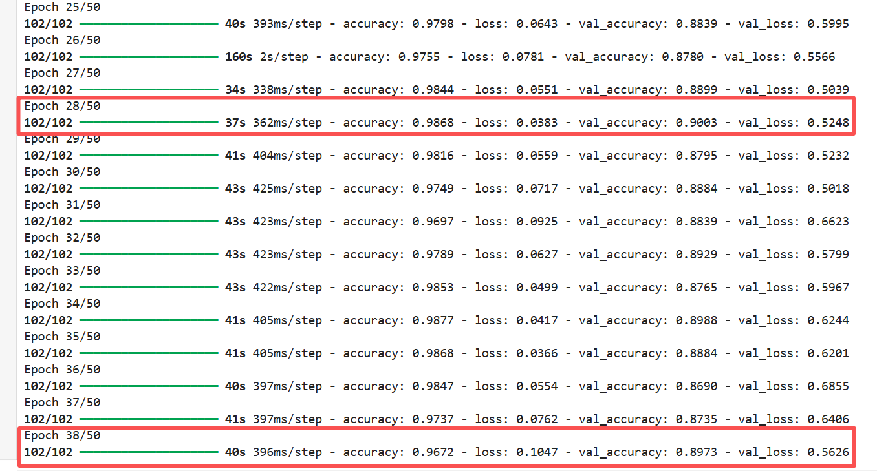
training image
Results
The model achieved a final accuracy rate of 98% on the training set, indicating that it could adequately fit the training data. However, the accuracy rate on the validation set was 90%, and on the independent test set it was 85%. These data suggest that although the model can effectively learn the features of the training data, its generalization ability decreases when exposed to unseen data.
To better visualize the training process and the convergence of the model, curves (Model curve graph) depicting the changes in training, validation, and test accuracy over the number of training rounds were plotted. The curves show that the training accuracy rises rapidly and stabilizes at a relatively high level, while the accuracy of the validation and test sets is slightly lower and shows some fluctuations. This indicates that the model fits the training data well during the learning process, but its adaptability to new samples is slightly insufficient. This further suggests that regularization or data augmentation may have room for improvement.
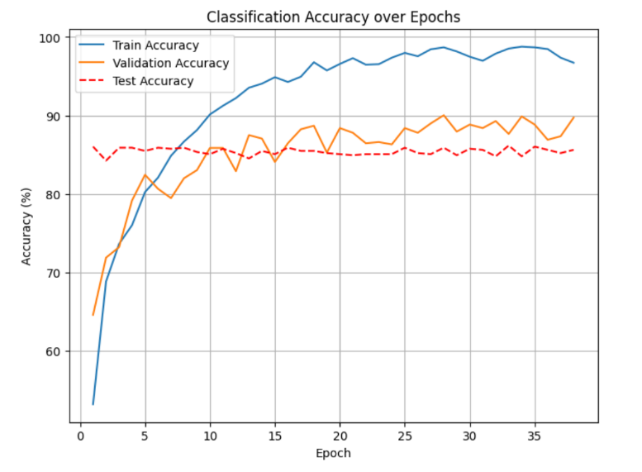
Model curve graph
The confusion matrix (confusion matrix graph) provides an intuitive visualization of the model's classification performance across various categories. The majority of values on the diagonal are high, indicating that the majority of samples are correctly classified. However, there are many misclassifications between certain categories, such as samples of battery with similar luster or features to metal, which are prone to confusion. This phenomenon reflects the model's challenges in distinguishing between categories with similar textures or shapes, suggesting that future improvements can be made by enhancing feature extraction or increasing data diversity to optimize performance.
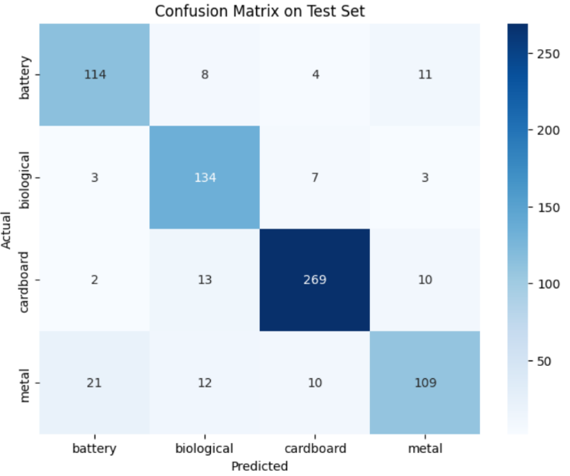
confusion matrix graph
Although the training accuracy reached 98%, the validation and test accuracies dropped significantly to 90% and 85% respectively, indicating that the model has a certain degree of overfitting. Possible reasons include: 1. The dataset size is moderate, with limited sample numbers, making the model prone to memorizing the training samples. 2. The network depth and parameter quantity are large, which makes it prone to overfitting on small datasets. 3. There is visual similarity among categories, making some categories difficult to distinguish. Therefore, future improvement directions could include increasing the data volume, using stronger data augmentation methods, introducing regularization techniques (such as Dropout, weight decay), or trying a deeper CNN architecture.
Conclusion
The convolutional neural network (CNN) constructed in this experiment demonstrates strong feature learning ability and overall classification performance in the image classification task. The accuracy rate of the training set reaches 98%, the accuracy rate of the validation set is 90%, and the accuracy rate of the test set is 85%. This indicates that the model can effectively fit the training data, but there is a certain decline in its generalization ability on unseen samples. This difference reflects that the model may exhibit a certain degree of overfitting under the condition of limited data. Through the analysis of the training accuracy, validation accuracy, and test accuracy curves, it can be observed that the model converges rapidly in the early stage of training, while the accuracy rates of the validation and test sets are slightly lower and fluctuate relatively smoothly, indicating a stable training process, but still facing certain generalization challenges.
Further analysis through the confusion matrix revealed that the model performed well in most categories, but there were still some misjudgments for categories with similar features or textures (such as battery and metal). This indicates that the model still has room for improvement in distinguishing fine-grained features of similar categories. To enhance the generalization ability and classification accuracy of the model, future research could consider expanding the dataset size, enhancing data diversity, introducing more powerful data augmentation techniques, and optimizing the network structure and regularization methods, such as increasing the Dropout ratio or using weight decay.

References
(Basha et al.,2020)Basha S.,Dubey S.,Pulabaigari V.,Mukherjee S.,Impact of fully connected layers on performance of convolutional neural networks for image classification,https://www.sciencedirect.com/science/article/pii/S0925231219313803,2020.
(Huang et al.,2023)Huang L.,Qin J.,Zhou Y.,Zhu F.,Liu L.,Shao L.,Normalization Techniques in Training DNNs: Methodology, Analysis and Application,IEE,https://ieeexplore.ieee.org/document/10056354,2023.
(Janiesch et al.,2021)Janiesch C.,Zschech P.,Heinrich K.,Machine learning and deep learning,link.springer,https://link.springer.com/content/pdf/10.1007/s12525-021-00475-2.pdf,2021.
(Maier et al.,2023)Maier H.,Zheng F.,Gupta H.,Chen J.,Mai J.,Savic D.,Loritz R.,Wu W.,Guo D.,Bennett A.,Jakeman A.,Razavi S.,Zhao J, On how data are partitioned in model development and evaluation,ciencedirect,https://www.sciencedirect.com/science/article/pii/S1364815223001652,2023.
(Pang et al.,2018)Pang Y.,Nember S.,IEEE.,Sun M.,Jiang X.,Li X., Convolution in Convolution for Network in Network,IEEE,https://ieeexplore.ieee.org/stamp/stamp.jsp?tp=&arnumber=7879808,2018.
(Sun et al.,2017)Sun M.,Song Z.,Jiang X.,Pan J.,Pang Y.,Learning Pooling for Convolutional Neural Network,sciencedirect,https://www.sciencedirect.com/science/article/pii/S0925231216312905,2017.
(Zhang et al.,2022)Zhang C.,Dong H.,Geng Y.,Song X.,Zhang T.,Zhuang M., Conservation and Recycling,sciencedirect,https://www.sciencedirect.com/science/article/pii/S0921344922003640,2022.

